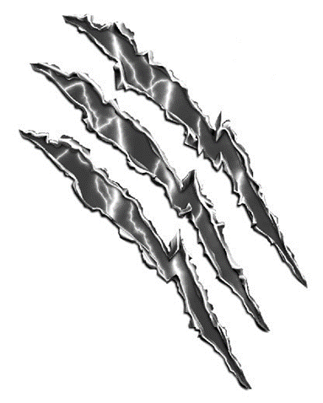
OPERATION joys WITH TOYS
Collections boxes will be set up at the main entrances of University, Science, Allgood, and Galloway Halls as well as outside the JSAC from 12 Sept.-21Nov.

Operation give is an organization that collects toys for the holiday season to send to children in Iraq.
What to give:
Toys: Dolls, cars and trucks, balls, especially soccer balls, plush toys and stuffed animals, plastic animals and dinosaurs, tool and cooking sets, puzzles, binoculars, Magna-Doodles, basic Lego’s, blocks, jump ropes, Frisbees, picture books, baby toys, stacking cups, shape sorters, chess sets
SCHOOL SUPPLIES: Notebook, paper, pencils, pencil sharpeners, pens, colored markers, ruler, eraser, binder, or calculator, etc
ART SUPPLIES: Colored pencils, pastels, markers, brushes, paint sets, paper chalk, coloring books, etc.
WHAT NOT TO GIVE:
NO: Toys that will not work without batteries, toys that require electricity, violent toys (guns, violent action figures), toys that shoot projectiles, Barbies or comparables
Sponsored BY:
The Ranger Club

